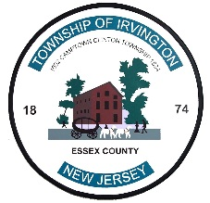
rvington Neighborhood
mprovement Corporation
I

Tony Vauss Deborah F. Simpkins
Mayor Executive Director

SERVICES OFFERED

The Irvington Neighborhood Improvement Corporation offers the following services:

• Daily Soup Kitchen/Feeding Station (Monday thru Friday, Breakfast 8:00am-9:00am, Lunch 12:00pm-1:00pm, Dinner 4:00pm-5:00pm)
• Emergency Rental Assistance
• Relocation Assistance
• Utility Assistance
• Mortgage Assistance
• Social Service Referrals
• Housing Counseling
• Financial Literacy Workshops
• Emergency Food Pantry
• Clothing Closet
• Afterschool program
• Afterschool snack and feeding program
• Monthly Food Pantry (4th Wednesdays, and Thursdays of the monthly) for registered participants who qualify.
• Seasonal Clothing & Household items Bazaars
• Supplementary Food & Gift
• Independent Living and Support Services for Senior
• Senior Breakfast Program (Monday & Wednesday, (9:00AM – 10:00AM)
• Pre-screenings/Registration for SNAP & GA Benefits (by appointment only)

