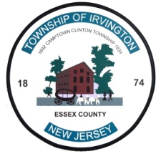  Anthony Vauss  Mayor | TOWNSHIP OF IRVINGTON  OFFICE OF THE TAX COLLECTOR  MUNICIPAL BUILDING  1 CIVIC SQUARE  IRVINGTON, NJ 07111  Tel. (973) 399-6613 Fax: (973) 399-6618  Website: www.irvington.net | Musa A. Malik  Acting Director  Faheem RaOof  CPA, CFO  Tyrone A. Young  Tax Collector

May 3, 2022

Re: Tax Lien on your Property

Dear Taxpayer,

This letter serves as a courtesy reminder to redeem the lien that may exist on your property. You can check the status of your property tax and sewer account by visiting us on the web at: www.irvvington.net and follow the highlighted illustrated steps below: 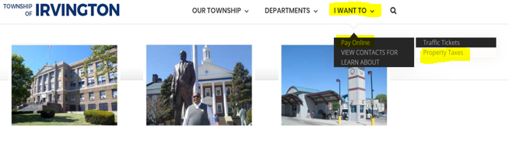
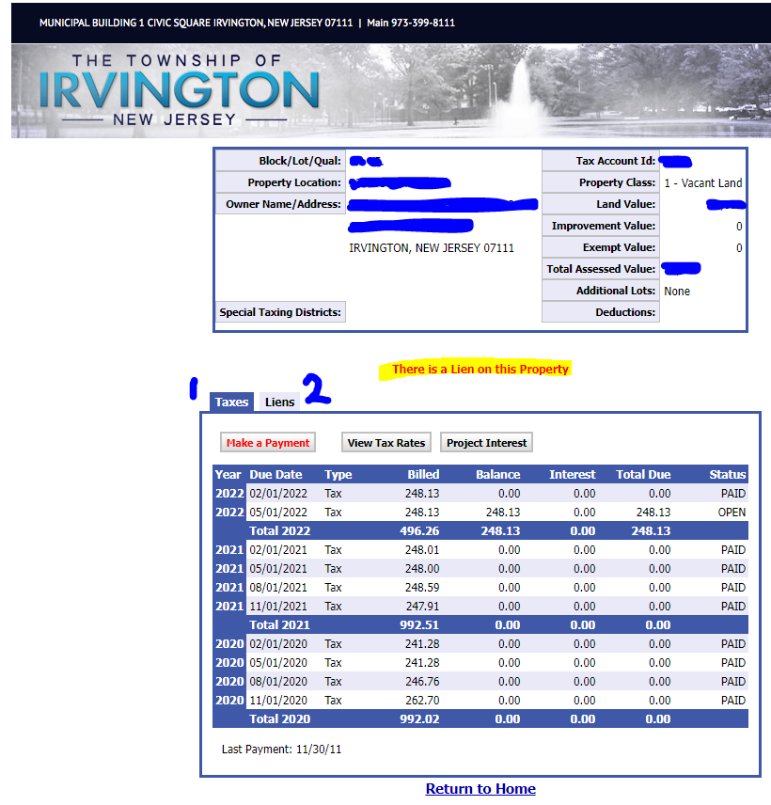
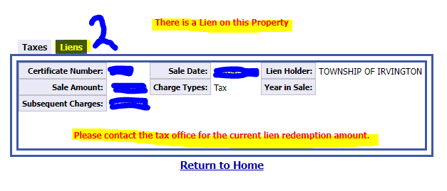
Should there be a lien that exists on your property, “There is a Lien on this Property” will appear in the center of the page, as illustrated above. Said certificate was acquired by the either the Township of Irvington or an outside third-party lienholder.

State statutes provide that certificates acquired by the municipality can be foreclosed any time after six (6) months after the date of sale and any time after two (2) years after the date of sale for a third-party lienholder. Subsequent taxes may also be accruing on your account.

Please note that if a property is deemed “abandoned,” immediate foreclosure actions can be taken.

Payment of a lien is not permitted via online services. You must complete, sign and return the attached “Lien Redemption Request” form. Please enter the date you anticipate paying on the line stating, “Please calculate figures though.” Include a copy of your valid photo identification card. If the property is not in your name, please provide proof of ownership or proof of interest in the property. In turn, the figures required to redeem said lien(s) will be provided to you.

If you wish to redeem the certificate(s) or have any questions, please contact this department at the 973-399-6613.

Thank you.

Respectfully,

Township of Irvington
Tax Department

